ALB Log store to s3 bucket

1. First open Application load balancer (eg.testalb) click on Action tab and select edit load balancer attributes.

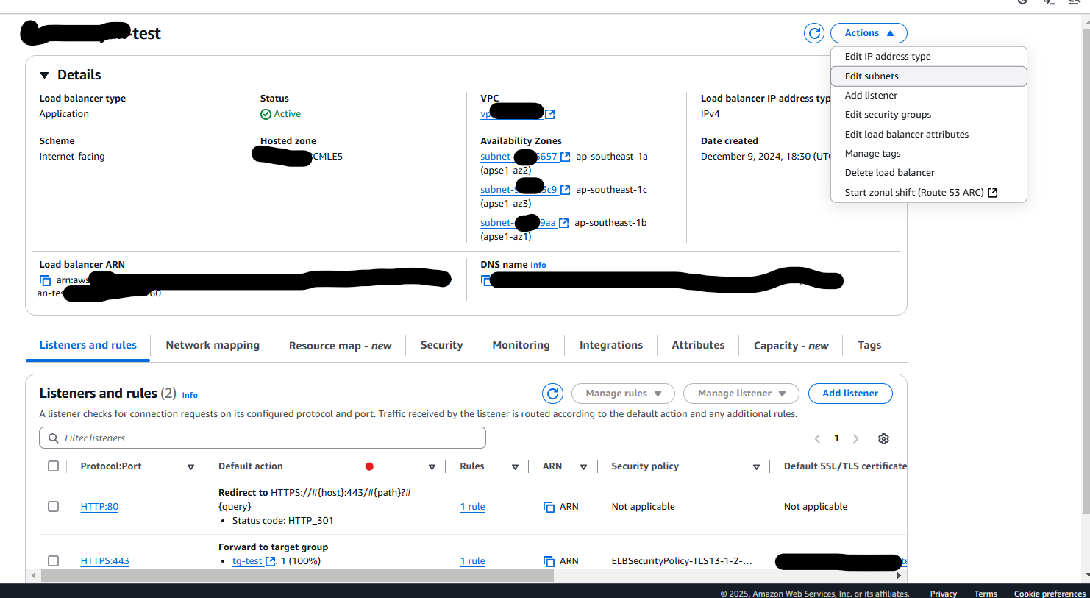

1. Drag Down the page and comes to a section of monitoring there is option Access logs and connection logs in disabled as default. Make enable it.

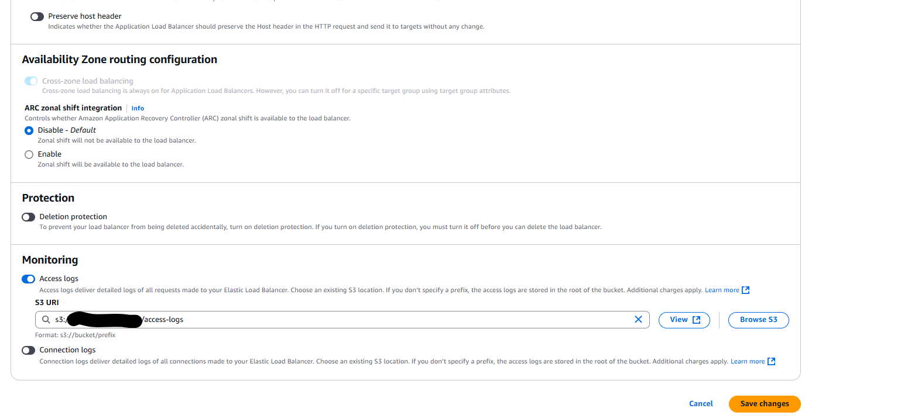

1. Go s3 create bucket with unique

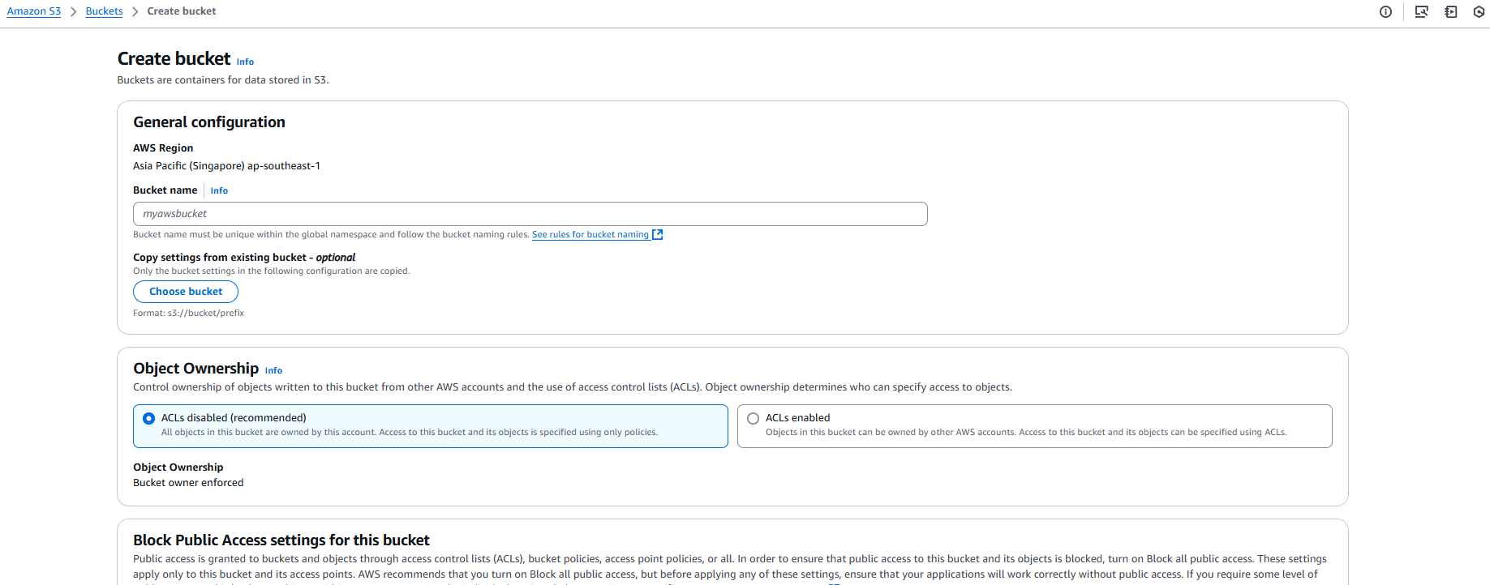

1. Add bucket policy there in permission inside bucket policy section
2. 